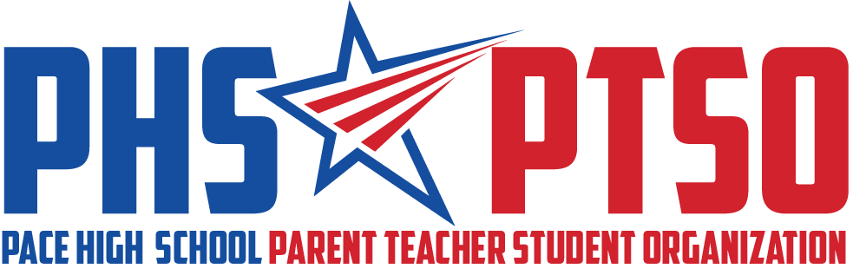

General Meeting Minutes
Tuesday, April 12, 2022

I. Call to Order

The meeting was called to order at 8:00am by President Cassandra Hazelwood.

II. Approval of Minutes

Secretary Roberta Panepinto reviewed the March 8, 2022 Meeting Minutes. Kimberly Booker motioned for the minutes to be approved and it was seconded by Lisa Avila. The motion passed unanimously.

III. Reports from Board

President's Report
President Cassandra Hazelwood thanked the board for all their contributions to the success of our organization.

Treasurer's Report
The balance of the PTSO bank account was $17,572.48 as of March 1, 2022. Our deposits for February were $3,665.83 and our expenses were $2275.59.

School Sponsor’s Report
Mrs. Cassevah thanked us for supporting the school and community. She said the Sonic Drink event was fun.

IV. Old Business

Sonic Drinks (Appreciation)
The event was a success for our teachers. Minor tweaks are needed going forward. The pre-printed drink labels helped tremendously. The event cost $100.

East Milton Elementary School (EMES) Luncheon (Appreciation & Community)
The event was a success. Pace High Principal Stephen Shell helped serve drinks with EMES Principal Ms. Colin to the staff and teachers. Santa Rosa County School Superintendent Karen Barber was in attendance. Volunteers from both EMES and Pace High executed the event. Many parents from EMES and Pace High donated desserts. The event cost was $300.

V. New and Ongoing Business

Teacher Appreciation Week (Appreciation)
Mrs. Cassevah mentioned that NHS and Beta might not be able to provide us snacks for Teacher Appreciation Week (TAW) due to bringing in so many items for Easter events. She will send the request of donations to all club sponsors. It was decided that we would send out a Facebook post requesting snacks and PTSO would give one volunteer hour for each donation. Mrs. Cassevah also said SGA and ROTC can help with table setup and icing drink during TAW. She mentioned Beta buying gift cards for the teachers through the processing support of PTSO. She stated that teachers are allowed to dress up for the decade during TAW. She suggested we do a “Best Dressed” and have a faculty picture each day at 8:15am. The administration has agreed to talk in the slang of the decade each day over the PA system. Roberta Panepinto stated that a Signup Genius would go out for desserts and volunteers two weeks before the event. She informed the board that Tuesday, Thursday and Friday are our big food days in the Drama Room.

2022-2023 Executive Officer Elections (Communication)
Carmen Bailiff made a motion to elect the Nominations Committee’s presented slate of Executive Officers. It was seconded by Sarah Baltimore. The motion passed unanimously.

The following are the elected 2022-2023 Executive Officers for Pace High School PTSO (EIN 84-4406705):
President: Roberta Panepinto
Co-Vice President: Lora Steele
Co-Vice President: Erica Ortiz
Treasurer: Tina Melder
Recording Secretary: Jennifer Smith
Communications Secretary: Natalie Lambert

Egg My Yard (Community)
Egg My Yard (EMY) will take place on April 16th. Basket prep is April 11, 2022. To date, we have $5455 in EMY sales. Our budgeted goal is $5000.

Student Scholarships (Enhancement)
Seven students submitted applications for the PTSO Scholarships that can be used at a 4-year college or technical trade school. Two $500 scholarships and a gift basket will be awarded. The committee that will review the applications is Cassandra Hazelwood, Celene Sessions (Media Specialist), Roberta Panepinto and Sarah Baltimore. All applicant names will be hidden when reviewed by the selection committee for equity. The scholarship checks and baskets will be presented at Senior Awards Night, May 9, 2022.

Painted Parking Lot Space Fundraiser (Community)
It was discussed that we will have to purchase the parking decals. The decals will cost $250.

Teacher Sponsorship: Personal Development (Enhancement)
We discussed using some of our residual enhancement money to support teachers that attend educational development conferences. We would like to have a one-page application and the budget would be $2500. Examples of types of conferences mentioned were STEM related or curriculum-based conferences, National Teacher Conferences, Education Summits, Ron Clark Academy, and Zero World Language workshops.

VI. Upcoming Events & Expenses

April 13th – Reading Café 8am-9:15am in Media Center ($200)
April 16th – EMY Basket Delivery ($2650)
April 18th – Scholarship Meeting
May 2nd – 6th – Teacher Appreciation Week ($2500)
May 7th – Prom
May 9th – Senior Awards/Scholarship ($1200)
May 10th – PTSO Transition Meeting at 8am
May – Insurance payment ($300) and Office Supplies ($150)
June/July - Rollover Expense ($2500) and Residual Enhancement Remainder ($7500)

VII. Adjourn

The meeting was adjourned at 8:37am. The following members were in attendance: Cassandra Hazelwood, Kimberly Booker, Lisa Avila, Erica Ortiz, Sarah Baltimore, Carmen Bailiff, Kelly Moore, Claudia Cassevah and Roberta Panepinto.

