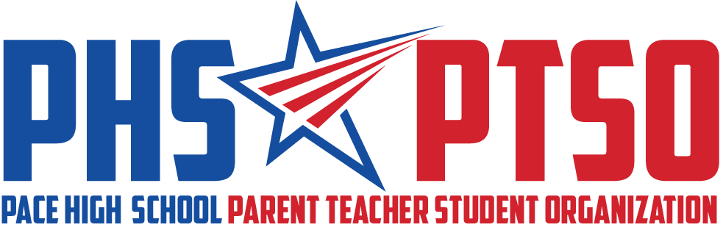

General Meeting Minutes
Tuesday, January 11, 2022

I. Call to Order

The meeting was called to order at 8:05am by President Cassandra Hazelwood.

II. Approval of Minutes

Secretary Roberta Panepinto reviewed the November 9, 2021, Meeting Minutes. Jennifer Smith motioned for the minutes to be approved and it was seconded by Tina Melder. The motion passed unanimously.

III. Reports from Board

President's Report
Cassandra Hazelwood informed us that we will not have a February meeting due to our workload. She is still working with Mr. Shell to get approval for the student painted parking spot fundraiser.

Treasurer's Report
The balance of the PTSO bank account was $18,223.60 as of December 31, 2021. Our deposits for December were $1,305.16 and our expenses were $1,160.66. Our budgeted goal is $33,602.72. Please turn in reimbursement requests to Jennifer or Cassandra.

School Sponsor’s Report
Mrs. Cassevah thanked us for supporting the school and community and said the Christmas luncheon was awesome. She asked us to spread the work about SGA’s Masquerade Dance on Feb. 12, 2022. Ms. Cassevah stated that teachers said they would be interested in paying money to paint their own personal parking spot as a fundraiser idea.

IV. Old Business

Grants (Enhancement)
Grants Coordinator, Danielle Baker stated Teacher Certificates went out to the winners before Thanksgiving break. An email was sent to all of the winners to use their funds by January 31, 2022. We will use $3,000.00 by this date and Ms. Whitfield is who they work with to get their funds.

Fundraising (Community)
We need to sell 8 more LED sign Birthday messages to get to our budgeted goal of $2000. Birthday messages are $20. Mr. Goodwin is in charge of posting the messages on the LED marque.

Membership (Community)
Erica Ortiz, membership chair, stated that all business letters have gone out and we might get a few more around tax time. We have 10% of teachers that have not signed up for PTSO membership. Ms. Cassevah said if we get her the list of teachers, she will go around personally and talk to them.

Marketing and Communications Update (Communication)
What’s Happening post will now be sent out on media outlets Sunday nights. Use GroupMe or FB messenger for school happenings. If you have ideas for Parent Resources, please send them to Natalie. We will be doing a refresh of the website during the 3rd nine weeks (January 2022).

V. New and Ongoing Business

Reading Café/Book Fair (Enhancement)
Book Fair will happen Feb 7th – 11th. Setup will be Feb. 3rd, specifically decorating at 11am and setup 1p-3p. There will be a teacher preview on the 4th with coffee. Teachers will make a Book Wishlist that will be posted online. We will post a volunteer signup two weeks before the event (Jan 24th week). We will need 4-5 volunteers per day and a board member. All students will go to the book fair during their history class. Ms. Sessions has student volunteers available. Reading Café will coincide with the book fair on Feb. 8th. Setup for the Café will be on the 7th, after the book fair and again on the 8th at 7:15am for the 8am event. We will accept payment cash, check or Venmo payment. We will partner with the Guidance department to have gift certificates available for students in need.

East Milton Elementary PTO (Community)
Mr. Shell asked if we could do breakfast for their staff of 50, since they have a very limited parent support group. We discussed that we will work with their current PTO to provide resources and a breakfast.

Ted Wiese Leadership Workshop (Enhancement)
The Leadership workshop is scheduled for Feb. 23rd – 25th. We have had a request to provide daily lunch for 150 students. Lori Newcomer motioned to approve $1000 for pizza and water to the attendees and it was seconded by Lora Steele. The motion passed unanimously.

Nominations Committee (Communication)
The Nominations Committee will be chaired by Kimberly Booker. Membership Chair Erica Ortiz and School Sponsor Claudia Cassevah will serve on the committee. Elections are held at the General Meeting in April, in compliance with our bylaws.

VI. Upcoming Events

Jan 21st – Bus Driver Appreciation and Member’s Only Teacher/Staff Appreciation Drawing event
Feb 4th – Coffee in Media Center for teacher Book Fair Preview
Feb 7th – 11th – Book Fair
Feb 8th – Reading Café
Mar TBD – Member’s Only Teacher/Staff Mailbox Treat
Mar 8th – PTSO Meeting at 8am, Cassevah’s room
April TBD – Reading Café and Member’s Only Teacher/Staff Appreciation Sonic Drinks
May 2nd – 6th – Teacher Appreciation Week

VII. Adjourn

The meeting was adjourned at 8:58am. The following members were in attendance: Cassandra Hazelwood, Kimberly Booker, Danielle Baker, Kelly Moore, Lisa Avila, Lori Newcomer, Erica Ortiz, Lora Steele, Kelly Moore, Tina Melder, Kandy McGinnis, Jennifer Moore, Irene Garrett, Sarah Thompson, Claudia Cassevah and Roberta Panepinto.

